**UNIVERSIDAD PRIVADA FRANZ TAMAYO**

**FACULTAD DE INGENIERÍA**

**CARRERA DE INGENIERÍA DE SISTEMAS**



**TAREA FINAL HITO 3**

**Nombre Completo: Univ. Sarai Leslie A lvarez**

**Asignatura: Sistemas Móviles y Embebidos**

**Carrera: INGENIERÍA DE SISTEMAS**

**Paralelo: SOM (1)**

**Docente: Lic. William R. Barra Paredes**

**Cochabamba-2020**

**1 capturas de omboarding**

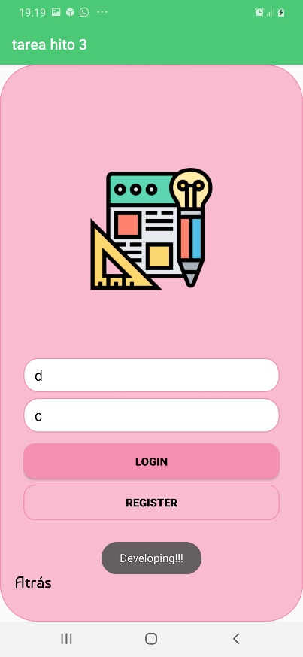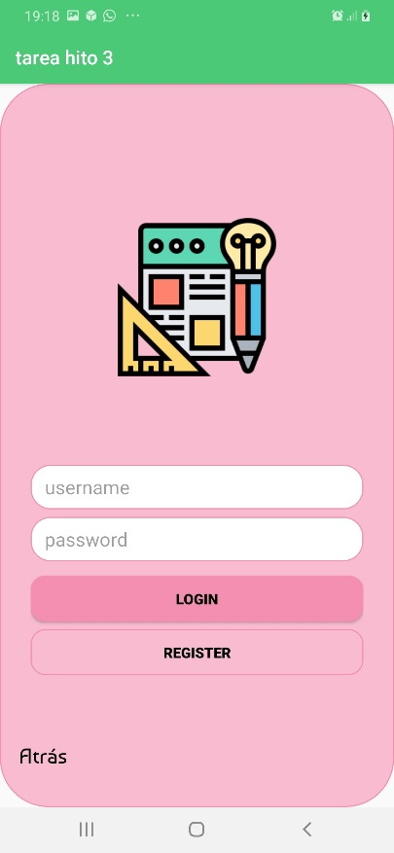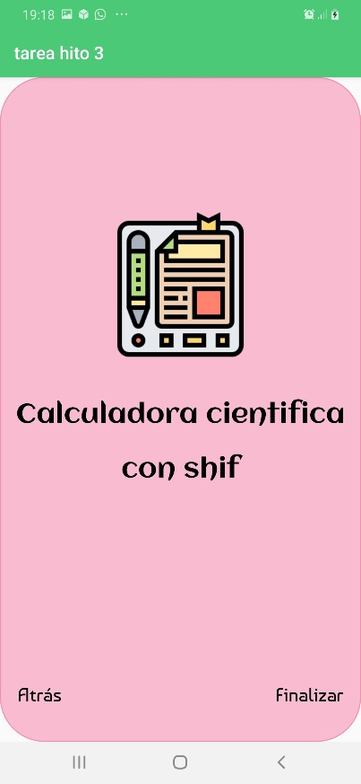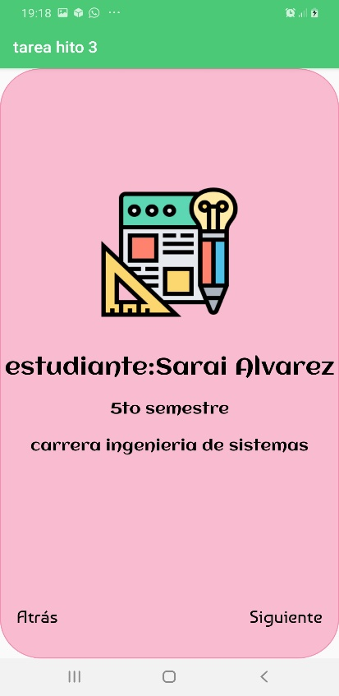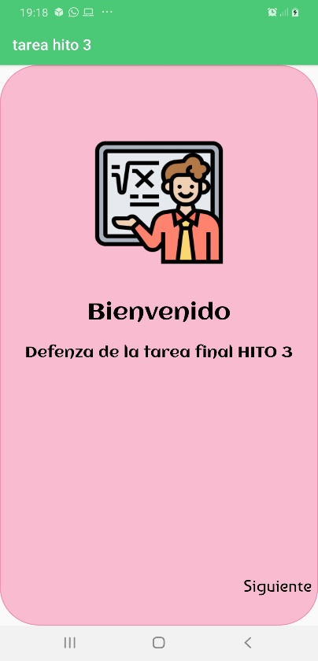

**2 capturas de la calculadora**

**Codigo java de la calculadora**

import androidx.appcompat.app.AppCompatActivity;  
import android.os.Bundle;  
import android.view.View;  
import android.widget.Button;  
import android.widget.EditText;  
import android.widget.TextView;  
import com.test.umboarding.R;  
public class App extends AppCompatActivity {  
 private boolean EO=false;  
 private EditText pantalla;  
 private Button b1,b2,b3,b4,b5,b6,b7,b8,b9,b0;  
 private Button suma,resta,mul,divi,igu;  
 private Button punto, porsen, cm, facc,senn,tng,raiz,cos,shift,borrar;  
 private double aux1=0,aux2=0;  
 private String aux3="";  
 private char letra;  
 @Override  
 protected void onCreate(Bundle savedInstanceState) {  
 super.onCreate(savedInstanceState);  
 setContentView(R.layout.*fragment_calculadora*);  
 _initialize();  
 _addClickDoneAndPrev(); }  
 public void _initialize() {  
 senn=(Button)findViewById(R.id.*senn*);  
 tng=(Button)findViewById(R.id.*tng*);  
 raiz=(Button)findViewById(R.id.*raiz*);  
 cos =(Button)findViewById(R.id.*cos*);  
 borrar= (Button) findViewById(R.id.*btborrar*);  
 punto = (Button) findViewById(R.id.*punto*);  
 porsen= (Button) findViewById(R.id.*porcentaje*);  
 cm= (Button) findViewById(R.id.*cm*);  
 facc= (Button) findViewById(R.id.*facc*);  
 b0=(Button)findViewById(R.id.*b0*);  
 b1=(Button)findViewById(R.id.*b1*);  
 b2=(Button)findViewById(R.id.*b2*);  
 b3=(Button)findViewById(R.id.*b3*);  
 b4=(Button)findViewById(R.id.*b4*);  
 b5=(Button)findViewById(R.id.*b5*);  
 b6=(Button)findViewById(R.id.*b6*);  
 b7=(Button)findViewById(R.id.*b7*);  
 b8=(Button)findViewById(R.id.*b8*);  
 b9=(Button)findViewById(R.id.*b9*);  
 suma=(Button)findViewById(R.id.*editsum*);  
 resta=(Button)findViewById(R.id.*editres*);  
 mul=(Button)findViewById(R.id.*editmul*);  
 divi=(Button)findViewById(R.id.*editdiv*);  
 igu=(Button)findViewById(R.id.*editigual*);  
 pantalla=(EditText)findViewById(R.id.*caja*);  
 C=(Button)findViewById(R.id.*editlimpiar*);  
 senn=(Button)findViewById(R.id.*senn*);  
 tng=(Button)findViewById(R.id.*tng*);  
 raiz=(Button)findViewById(R.id.*raiz*);  
 cos =(Button)findViewById(R.id.*cos*);  
 shift=(Button)findViewById(R.id.*btnshift*); }  
 public void _addClickDoneAndPrev() {  
 b0.setOnClickListener(new View.OnClickListener() {  
 @Override  
 public void onClick(View v) {  
 aux3=pantalla.getText().toString();  
 aux3+=0;  
 pantalla.setText(aux3); } });  
 b1.setOnClickListener(new View.OnClickListener() {  
 @Override  
 public void onClick(View v) {  
 aux3=pantalla.getText().toString();  
 aux3+=1;  
 pantalla.setText(aux3); } });  
 b2.setOnClickListener(new View.OnClickListener() {  
 @Override  
 public void onClick(View v) {  
 aux3=pantalla.getText().toString();  
 aux3+=2;  
 pantalla.setText(aux3); } });  
 b3.setOnClickListener(new View.OnClickListener() {  
 @Override  
 public void onClick(View v) {  
 aux3=pantalla.getText().toString();  
 aux3+=3;  
 pantalla.setText(aux3); } });  
 b4.setOnClickListener(new View.OnClickListener() {  
 @Override  
 public void onClick(View v) {  
 aux3=pantalla.getText().toString();  
 aux3+=4;  
 pantalla.setText(aux3); } });  
 b5.setOnClickListener(new View.OnClickListener() {  
 @Override  
 public void onClick(View v) {  
 aux3=pantalla.getText().toString();  
 aux3+=5;  
 pantalla.setText(aux3); } });  
 b6.setOnClickListener(new View.OnClickListener() {  
 @Override  
 public void onClick(View v) {  
 aux3=pantalla.getText().toString();  
 aux3+=6;  
 pantalla.setText(aux3); } });  
 b7.setOnClickListener(new View.OnClickListener() {  
 @Override  
 public void onClick(View v) {  
 aux3=pantalla.getText().toString();  
 aux3+=7;  
 pantalla.setText(aux3); } });  
 b8.setOnClickListener(new View.OnClickListener() {  
 @Override  
 public void onClick(View v) {  
 aux3=pantalla.getText().toString();  
 aux3+=8;  
 pantalla.setText(aux3); } });  
 b9.setOnClickListener(new View.OnClickListener() {  
 @Override  
 public void onClick(View v) {  
 aux3=pantalla.getText().toString();  
 aux3+=9;  
 pantalla.setText(aux3); } });  
 punto.setOnClickListener(new View.OnClickListener(){  
 public void onClick(View v){  
 aux3 = pantalla.getText().toString();  
 aux3 =aux3 + ".";  
 pantalla.setText(aux3); } });  
 porsen.setOnClickListener(new View.OnClickListener()  
 { public void onClick(View v){  
 aux1=Double.*parseDouble*(pantalla.getText().toString());  
 pantalla.setText("");  
 letra='s'; } });  
 cm.setOnClickListener(new View.OnClickListener()  
 { public void onClick(View v){  
 aux3 = pantalla.getText().toString();  
 aux3 =aux3 + "1";  
 aux2 = Double.*parseDouble*(pantalla.getText().toString())* (-1);  
 pantalla.setText(String.*valueOf*(aux2)); } });  
 suma.setOnClickListener(new View.OnClickListener() {  
 @Override  
 public void onClick(View v) {  
 if(aux1==0)  
 { aux1=Double.*parseDouble*(pantalla.getText().toString());  
 } else  
 { aux1+=Double.*parseDouble*(pantalla.getText().toString());  
 } pantalla.setText("");  
 letra='+'; } });  
 resta.setOnClickListener(new View.OnClickListener() {  
 @Override  
 public void onClick(View v) {  
 if(aux1==0)  
 { aux1=Double.*parseDouble*(pantalla.getText().toString()); } else  
 { aux1-=Double.*parseDouble*(pantalla.getText().toString());  
 } pantalla.setText("");  
 letra='-'; } });  
 mul.setOnClickListener(new View.OnClickListener() {  
 @Override  
 public void onClick(View v) {  
 if(aux1==0)  
 { aux1=Double.*parseDouble*(pantalla.getText().toString());  
 } else  
 {aux1*=Double.*parseDouble*(pantalla.getText().toString()); }  
 pantalla.setText("");  
 letra='*'; } });  
 divi.setOnClickListener(new View.OnClickListener() {  
 @Override  
 public void onClick(View v) {  
 if(aux1==0)  
 {aux1=Double.*parseDouble*(pantalla.getText().toString());  
 } else  
 { aux1/=Double.*parseDouble*(pantalla.getText().toString());  
 } pantalla.setText("");  
 letra='/'; } });  
 C.setOnClickListener(new View.OnClickListener() {  
 @Override  
 public void onClick(View v) {  
 aux1=0;  
 aux2=0;  
 aux3="";  
 letra=' ';  
 pantalla.setText(""); } });  
 borrar.setOnClickListener(new View.OnClickListener(){  
 public void onClick(View v){  
 if(aux3.length()>0)  
 { aux3 =pantalla.getText().toString();  
 aux3 = aux3.substring(0,aux3.length()-1);  
 pantalla.setText(aux3);} } });  
 facc.setOnClickListener(new View.OnClickListener() {  
 @Override  
 public void onClick(View v) {  
 double x,x2=1;  
 x=Double.*parseDouble*(pantalla.getText().toString());  
 for(int i=1;i<=x;i++)  
 { x2*=i; }  
 pantalla.setText(""+x2); } });  
 igu.setOnClickListener(new View.OnClickListener() {  
 @Override  
 public void onClick(View v) {  
 aux2=Double.*parseDouble*(pantalla.getText().toString());  
 pantalla.setText("");  
 switch (letra)  
 { case '+': { pantalla.setText(""+ (aux1+aux2)); break; } case '-': {  
 pantalla.setText(""+ (aux1-aux2));  
 break; } case '*': {  
 pantalla.setText(""+ (aux1*aux2));  
 break; } case '/':  
 { pantalla.setText(""+ (aux1/aux2));  
 break; } case 's':  
 { pantalla.setText(""+(aux2*aux1)/100);  
 break; } case 'x':  
 { pantalla.setText(""+(Math.*pow*(aux1,aux2)));  
 break; } } } });  
 shift.setOnClickListener(new View.OnClickListener() {  
 @Override  
 public void onClick(View v) {  
 if(EO==false)  
 { raiz.setText("X^_");  
 cos.setText("COS-1");  
 senn.setText("SEN-1");  
 tng.setText("X^2");  
 EO=true; }  
 else { raiz.setText("√");  
 cos.setText("COS");  
 senn.setText("SEN");  
 tng.setText("TNG");  
 EO=false; } } });  
 raiz.setOnClickListener(new View.OnClickListener() {  
 @Override  
 public void onClick(View v) { double x2;  
 x2=Double.*parseDouble*(pantalla.getText().toString());  
 if(EO==false)  
 { pantalla.setText(""+(Math.*sqrt*(x2))); }  
 else{ aux1=Double.*parseDouble*(pantalla.getText().toString());  
 pantalla.setText("");  
 letra='x'; } } });  
 cos.setOnClickListener(new View.OnClickListener() {  
 @Override  
 public void onClick(View v) { double x,x2;  
 x=Double.*parseDouble*(pantalla.getText().toString());  
 if(EO==false)  
 { pantalla.setText(""+(Math.*cos*(x))); }  
 else { x2=Math.*cos*(x);  
 pantalla.setText(""+(Math.*pow*(x2,-1))); } }});  
 tng.setOnClickListener(new View.OnClickListener() {  
 @Override  
 public void onClick(View v) {  
 double x1;  
 x1=Double.*parseDouble*(pantalla.getText().toString());  
 if(EO==false)  
 { pantalla.setText(""+(Math.*tan*(x1))); }  
 else{ pantalla.setText(""+(Math.*pow*(x1,2))); } } });  
 senn.setOnClickListener(new View.OnClickListener() {  
 @Override  
 public void onClick(View v) {  
 double x,x2; x=Double.*parseDouble*(pantalla.getText().toString());  
 if(EO==false)  
 {pantalla.setText(""+(Math.*sin*(x))); }  
 else{ x2=Math.*sin*(x);  
 pantalla.setText(""+(Math.*pow*(x2,-1))); }} }); }}

**Código xml de la calculadora**

<?xml version="1.0" encoding="utf-8"?>  
<RelativeLayout xmlns:android="http://schemas.android.com/apk/res/android"  
 xmlns:app="http://schemas.android.com/apk/res-auto"  
 xmlns:tools="http://schemas.android.com/tools"  
 android:layout_width="match_parent"  
 android:layout_height="match_parent"  
 android:background="@drawable/fondo"  
 tools:context=".App.App">  
 <LinearLayout  
 android:layout_width="match_parent"  
 android:layout_height="wrap_content"  
 android:gravity="center"  
 android:layout_marginTop="40dp"  
 android:orientation="vertical"  
 >  
 <TextView  
 android:layout_width="wrap_content"  
 android:layout_height="wrap_content"  
 android:text="@string/cientifica"  
 android:textSize="30dp"  
 />  
 <TextView  
 android:layout_width="wrap_content"  
 android:layout_height="wrap_content"  
 android:text="@string/nombre"  
 android:textSize="30dp"  
 />  
 <EditText  
 android:id="@+id/caja"  
 android:layout_width="match_parent"  
 android:layout_height="wrap_content"  
 android:layout_margin="27dp"  
 android:background="@drawable/cajas"  
 android:gravity="center"  
 android:padding="15dp"  
 android:textColor="#000000"  
 android:textSize="20sp" />  
 <LinearLayout  
 android:layout_width="wrap_content"  
 android:layout_height="wrap_content"  
 android:layout_marginTop="10dp" >  
 <Button  
 android:id="@+id/raiz"  
 android:layout_width="wrap_content"  
 android:layout_height="wrap_content"  
 android:text="√"  
 android:background="@drawable/botones"/>  
 <Button  
 android:id="@+id/cos"  
 android:layout_width="wrap_content"  
 android:layout_height="wrap_content"  
 android:text="COS"  
 android:background="@drawable/botones"/>  
 <Button  
 android:id="@+id/senn"  
 android:layout_width="wrap_content"  
 android:layout_height="wrap_content"  
 android:text="SEN"  
 android:textSize="13sp"  
 android:background="@drawable/botones" />  
 <Button  
 android:id="@+id/tng"  
 android:layout_width="wrap_content"  
 android:layout_height="wrap_content"  
 android:text="TNG"  
 android:background="@drawable/botones"/>  
 </LinearLayout>   
 <LinearLayout  
 android:layout_width="wrap_content"  
 android:layout_height="wrap_content"  
 android:layout_marginTop="10dp">  
 <Button  
 android:id="@+id/b7"  
 android:layout_width="wrap_content"  
 android:layout_height="wrap_content"  
 android:text="7"  
 android:background="@drawable/botones" />  
 <Button  
 android:id="@+id/b8"  
 android:layout_width="wrap_content"  
 android:layout_height="wrap_content"  
 android:text="8"  
 android:background="@drawable/botones"/>  
 <Button  
 android:id="@+id/cm"  
 android:layout_width="wrap_content"  
 android:layout_height="wrap_content"  
 android:text="+/-"  
 android:background="@drawable/botones"/>  
 <Button  
 android:id="@+id/facc"  
 android:layout_width="wrap_content"  
 android:layout_height="wrap_content"  
 android:text="FAC"  
 android:background="@drawable/botones"/>  
 </LinearLayout>  
 <LinearLayout  
 android:layout_width="wrap_content"  
 android:layout_height="wrap_content"  
 android:layout_marginTop="10dp">  
 <Button  
 android:id="@+id/b9"  
 android:layout_width="wrap_content"  
 android:layout_height="wrap_content"  
 android:text="9"  
 android:background="@drawable/botones"/>  
 <Button  
 android:id="@+id/b4"  
 android:layout_width="wrap_content"  
 android:layout_height="wrap_content"  
 android:text="4"  
 android:background="@drawable/botones"/>  
  
 <Button  
 android:id="@+id/editlimpiar"  
 android:layout_width="wrap_content"  
 android:layout_height="wrap_content"  
 android:background="@drawable/botones"  
 android:text="C" />  
 <Button  
 android:id="@+id/btborrar"  
 android:layout_width="wrap_content"  
 android:layout_height="wrap_content"  
 android:text="borrar"  
 android:background="@drawable/botones"/>  
 </LinearLayout>  
 <LinearLayout  
 android:layout_width="wrap_content"  
 android:layout_height="wrap_content"  
 android:layout_marginTop="10dp" >  
 <Button  
 android:id="@+id/b5"  
 android:layout_width="wrap_content"  
 android:layout_height="wrap_content"  
 android:text="5"  
 android:background="@drawable/botones"/>  
 <Button  
 android:id="@+id/b6"  
 android:layout_width="wrap_content"  
 android:layout_height="wrap_content"  
 android:text="6"  
 android:background="@drawable/botones"/>  
 <Button  
 android:id="@+id/editres"  
 android:layout_width="wrap_content"  
 android:layout_height="wrap_content"  
 android:text="-"  
 android:background="@drawable/botones"/>  
 <Button  
 android:id="@+id/editsum"  
 android:layout_width="wrap_content"  
 android:layout_height="wrap_content"  
 android:text="+"  
 android:background="@drawable/botones"/>  
 </LinearLayout>  
 <LinearLayout  
 android:layout_width="wrap_content"  
 android:layout_height="wrap_content"  
 android:layout_marginTop="10dp" >  
 <Button  
 android:id="@+id/b1"  
 android:layout_width="wrap_content"  
 android:layout_height="wrap_content"  
 android:text="1"  
 android:background="@drawable/botones"/>  
 <Button  
 android:id="@+id/b2"  
 android:layout_width="wrap_content"  
 android:layout_height="wrap_content"  
 android:text="2"  
 android:background="@drawable/botones"/>  
 <Button  
 android:id="@+id/editdiv"  
 android:layout_width="wrap_content"  
 android:layout_height="wrap_content"  
 android:text="/"  
 android:background="@drawable/botones"/>  
 <Button  
 android:id="@+id/editmul"  
 android:layout_width="wrap_content"  
 android:layout_height="wrap_content"  
 android:text="X"  
 android:background="@drawable/botones"/>  
 </LinearLayout>   
 <LinearLayout  
 android:layout_width="wrap_content"  
 android:layout_height="wrap_content"  
 android:layout_marginTop="10dp" >  
 <Button  
 android:id="@+id/b3"  
 android:layout_width="wrap_content"  
 android:layout_height="wrap_content"  
 android:text="3"  
 android:background="@drawable/botones"/>  
 <Button  
 android:id="@+id/b0"  
 android:layout_width="wrap_content"  
 android:layout_height="wrap_content"  
 android:text="0"  
 android:background="@drawable/botones"/>  
 <Button  
 android:id="@+id/punto"  
 android:layout_width="wrap_content"  
 android:layout_height="wrap_content"  
 android:text="."  
 android:background="@drawable/botones"/>  
 <Button  
 android:id="@+id/porcentaje"  
 android:layout_width="wrap_content"  
 android:layout_height="wrap_content"  
 android:text="%"  
 android:background="@drawable/botones"/>  
 </LinearLayout>  
 <LinearLayout  
 android:layout_width="wrap_content"  
 android:layout_height="wrap_content"  
 android:layout_marginTop="10dp" >  
 <Button  
 android:id="@+id/btnshift"  
 android:layout_width="180dp"  
 android:layout_height="wrap_content"  
 android:text="SHIFT"  
 android:background="@drawable/cajas"/>  
 <Button  
 android:id="@+id/editigual"  
 android:layout_width="180dp"  
 android:layout_height="wrap_content"  
 android:text="="  
 android:background="@drawable/botones"/>  
 </LinearLayout>   
 </LinearLayout>  
</RelativeLayout>

